here are information from <https://www.osha.gov/etools/computer-workstations/components> ， This an official website of the United States government , U.S. department of labor, occupational safety and health Administration.

[**Computer Workstations**](https://www.osha.gov/etools/computer-workstations)**» Workstation Components**

**Selecting and arranging your workstation components**

Appropriate placement of the components and accessories for the desktop computer workstation will allow you to work in neutral body positions, help you perform more efficiently, and work more comfortably and safe.

A laptop workstation creates special challenges due to its computer design, size, and the variety of areas in which it is used. While many aspects of this eTool will be applicable to laptops, special considerations may be necessary when working with laptop units.

The following sections explain how to select and arrange specific workstation components.

**Chairs**

A chair that is well-designed and appropriately adjusted is an essential element of a safe and productive computer workstation. A good chair provides necessary support to the back, legs, buttocks, and arms, while reducing exposures to awkward postures, contact stress, and forceful exertions.

**Desks**

A well-designed and appropriately-adjusted desk will provide adequate clearance for your legs, allow proper placement of computer components and accessories, and minimize awkward postures and exertions.

[**Document Holders**](https://www.osha.gov/etools/computer-workstations/components/document-holders)

Document holders keep printed materials needed during computer tasks close to the user and the monitor. Appropriate placement of the holder may reduce or eliminate risk factors such as awkward head and neck postures, fatigue, headaches, and eye strain.

[**Keyboards**](https://www.osha.gov/etools/computer-workstations/components/keyboards)

Proper selection and arrangement of the computer keyboard helps reduce exposure to awkward postures, repetition, and contact stress.

[**Monitors**](https://www.osha.gov/etools/computer-workstations/components/monitors)

Choosing a suitable monitor and placing it in an appropriate position helps reduce exposure to forceful exertions, awkward postures, and overhead glare. This helps prevent possible health effects such as excessive fatigue, eye strain, and neck and back pain.

[**Pointer/ Mouse**](https://www.osha.gov/etools/computer-workstations/components/pointer-mouse)

In addition to the conventional mouse, there are trackballs, touch pads, finger tip joysticks, and pucks, to name a few. Selection and placement of a pointer/mouse is an important factor in creating a safe computer workstation.

[**Telephones**](https://www.osha.gov/etools/computer-workstations/components/telephones)

Telephones add to the convenience of a workstation; however, telephones have cords that can get tangled up, and can cause the user to assume awkward postures.

[**Wrist/Palm Supports**](https://www.osha.gov/etools/computer-workstations/components/wrist-palm-support)

Wrist or palm rests can also increase your comfort. Although opinions vary regarding the use of wrist/palm supports, proper use has been shown to reduce muscle activity and to facilitate neutral wrist angles.

1.[**Workstation Components**](https://www.osha.gov/etools/computer-workstations/components)**» Chairs**

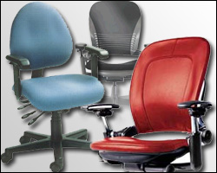

A chair that is well-designed and appropriately adjusted is an essential element of a safe and productive computer workstation. A good chair provides necessary support to the back, legs, buttocks, and arms, while reducing exposures to awkward postures, contact stress, and forceful exertions.

Increased adjustability ensures a better fit for the user, provides adequate support in a variety of [sitting postures](https://www.osha.gov/etools/computer-workstations/positions), and allows variability of sitting positions throughout the workday. This is particularly important if the chair has multiple users.

To ensure that the chair will provide adequate support, it is important that you try out different chairs before purchasing one.

The following parts of the chair are important elements to consider in creating a safe and productive workstation:

* Backrest
* Seat
* Armrest
* Base

You should adjust your chair along with appropriately placing your monitor, keyboard, and desk.

**Chair Quick Tips**

* The backrest should conform to the natural curvature of your spine, and provide adequate lumbar support.
* The seat should be comfortable and allow your feet to rest flat on the floor or footrest.
* Armrests, if provided, should be soft, allow your shoulders to relax and your elbows to stay close to your body.
* The chair should have a five-leg base with casters that allow easy movement along the floor.

**Here are details about different parts of chairs.**

1. **Backrest**

**Potential Hazard**

Poor back support and inappropriate postures may result from inadequate backrest size, material, positioning, or use. Working in these postures may lead to back pain and fatigue. For example, a chair without a suitable or adjustable backrest will not provide adequate lumbar support or help maintain the natural S-shape curvature of the spine.

**Possible Solutions**

* If your current chair does not have a lumbar support, use a rolled up towel or a removable back support cushion to temporarily provide support and maintain the natural curve of the spine.
* Use a chair with a backrest that is easily adjustable and able to support the back in a variety of [seated postures](https://www.osha.gov/etools/computer-workstations/positions). A backrest should have the following:
  + A lumbar support that is height adjustable so it can be appropriately placed to fit the lower back. The outward curve of the backrest should fit into the small of the back.
  + An adjustment that allows the user to recline at least 15 degrees from the vertical. The backrest should lock in place or be tension adjustable to provide adequate resistance to lower back movement.
  + A device enabling it to move forward and backward. This will allow shorter users to sit with their backs against the backrest without the front edge of the seat pan contacting their knees. Taller users will be able to sit with their backs against the backrest while still having their buttocks and thighs fully supported. *NOTE*: some chair designs provide this adjustability by adjusting the position of the seat pan.

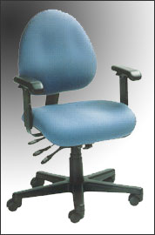

Figure 1. Adjustable chair and backrest

1. **Seat**

**Potential Hazard**

Using a chair with a seat that is too high may force you to work with your feet unsupported or encourage you to move forward in the chair to a point where your back is unsupported making it more difficult to maintain the S-shape of the spine (Figure 2). These awkward postures can lead to fatigue, restricted circulation, swelling, numbness, and pain.

**Possible Solutions**

* If the seat cannot be lowered (for example, it would make the keyboard or monitor too high), use a footrest to provide stable support for the feet (Figure 3).
* Provide a chair with a seat pan that is adjustable and large enough to provide support in a variety of [seated postures](https://www.osha.gov/etools/computer-workstations/positions). It is recommended that the seat should be
  + Height adjustable, especially when shared by a number of users. The chair height is appropriate when the entire sole of the foot can rest on the floor with the back of the knee slightly higher than the seat of the chair (Figure 4).
  + Padded and have a rounded, "waterfall" edge (Figure 5).
  + Wide enough to accommodate the majority of hip sizes. Chairs with oversize seat pans should be provided for larger users.

**Potential Hazard**

An inappropriately sized seat pan can be uncomfortable, provide inadequate support to the legs, and restrict movement. One that is too short can place excess pressure on the buttocks of taller users, one that is too long can place excess pressure on the knee area of shorter users and minimize back support. One that is too small can restrict movement and provide inadequate support. Prolonged use can restrict blood flow to the legs and create irritation and pain.

**Possible Solutions**

* Seat pan should be "depth" adjustable to adequately support taller users while allowing shorter users to sit with their back fully supported. The seat pan should provide support for most of the thigh without contact between the back of the user's knee and the front edge of the seat pan.
* Provide a footrest, which may elevate the knee slightly to relieve pressure on the back of the leg.
* Provide a chair that is sized to fit small or large users. *NOTE*: this is especially important if the chair is to be shared by several users.

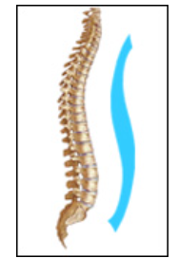

*Figure 2. Natural S-curvature of the spine*

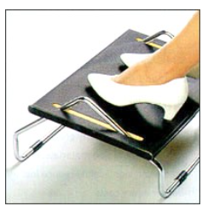

*Figure 3. Footrest*

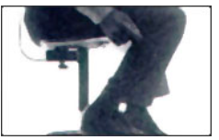

*Figure 4. Knee slightly higher than the seat of the chair*

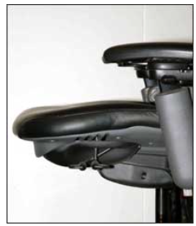

*Figure 5. Seat pan with a rounded, "waterfall" edge*

1. **Armrest**

**Potential Hazards**

**Note:** Using an armrest is up to you and the system integrators. Consider factors such as the amount of time during the workday that the user performs computer work, whether the user is experiencing or has experienced a musculoskeletal disorder (MSD) or [**symptoms**](https://www.osha.gov/etools/computer-workstations/components/chairs#msd), and user preference.

* Armrests that are not adjustable, or those that have not been properly adjusted, may expose you to [awkward postures](https://www.osha.gov/etools/computer-workstations/components/chairs#posture) or fail to provide adequate support. For example armrests that are:
  + *Too low* may cause you to lean over to the side to rest one forearm. This can result in uneven and awkward postures, fatiguing the neck, shoulders, and back.
  + *Too high* may cause you to maintain raised shoulders (Figure 6), which can result in muscle tension and fatigue in the neck and shoulders.
  + *Too wide* (Figure 6) cause you to reach with the elbow and bend forward for support. Reaching pulls the arm from the body and can result in muscle fatigue in the shoulders and neck.
  + *Too close* can restrict movement in and out of the chair.
  + *Too large* or inappropriately placed may interfere with the positioning of the chair. If the chair cannot be placed close enough to the keyboard, you may need to reach and lean forward in your chair. This can fatigue and strain the lower back, arm, and shoulder.
* Armrests that are made of hard materials or that have sharp corners can irritate the nerves and blood vessels located in the forearm. This irritation can create pain or tingling in the fingers, hand, and arm.

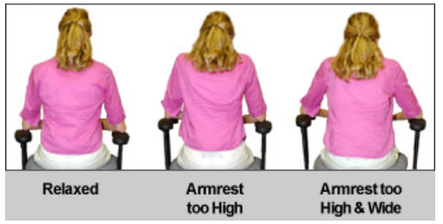

*Figure 6. Shoulders in various positions*

**Possible Solutions**

* If your armrests cannot be properly adjusted, or if they interfere with your workstation, remove them, or stop using them.
* Position adjustable armrests so they support your lower arm and allow your upper arm to remain close to the torso. Properly adjusted armrests will be
  + Wide enough to allow easy entrance and exit from the chair,
  + Close enough to provide support for your lower arms while keeping your upper arms close to the body,
  + Low enough so your shoulders are relaxed during use (Figure 6) (Adjust your armrests so they just make contact with your lower arms when positioned comfortably at your sides.), and
  + High enough to provide support for your lower arms when positioned comfortably at your sides. You may be able to add padding to the top of your armrests if they are too low and not adjustable.
* Armrests should be large enough to support most of your lower arm but small enough so they do not interfere with chair positioning.
* Armrests should be made of a soft material and have rounded edges.

1. Base

**Potential Hazards**

* Chairs with four or fewer legs may provide inadequate support and are prone to tipping.
* Inappropriate choice of casters, or a chair without casters, can make positioning the chair in relation to the desk difficult. This increases reaching and bending to access computer components, which can lead to muscle strain, and fatigue.

**Possible Solutions**

* Chairs should have a strong, five-legged base.
* Ensure that chairs have casters that are appropriate for the type of flooring at the workstation.

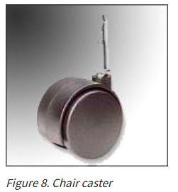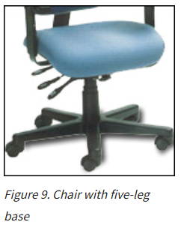

2.[Workstation Components](https://www.osha.gov/etools/computer-workstations/components) » Desks

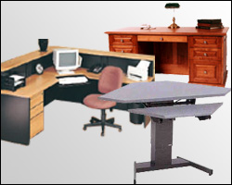

A well-designed and appropriately-adjusted desk will provide adequate clearance for your legs, allow proper placement of computer components and accessories, and minimize awkward postures and exertions. The installation, setup, and configuration of comfortable and productive workstations involves the following considerations:

* [Desk or work surface areas](https://www.osha.gov/etools/computer-workstations/components/desks#accordion-70047-collapse1)
* [Areas under the desk or work surface](https://www.osha.gov/etools/computer-workstations/components/desks#accordion-70047-collapse2)

**Here are details about different parts of chairs.**

1. Desk or work surface areas

**Potential Hazard**

Limited space on the work surface may cause users to place components and devices in undesirable positions. This placement may lead to [awkward postures](https://www.osha.gov/etools/computer-workstations/components/desks#posture) as you reach for a pointer/mouse or look at a monitor that is placed to the side.

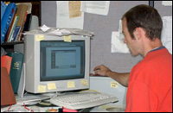Figure 1. Poor mouse and keyboard placement because of desktop clutter

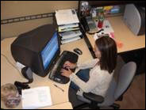Figure 2. Corner units provide additional depth and workspace

**Possible Solutions**

* Work surface depth should allow you to:
  + View the monitor at a distance of *at least* 20 inches (50 cm).
  + Position the [monitor](https://www.osha.gov/etools/computer-workstations/components/monitors) to achieve the appropriate [viewing angle](https://www.osha.gov/etools/computer-workstations/components/monitors#accordion-70080-collapse2), which is generally directly in front of you.
* Using a corner rather than a straight run of desk may provide additional space and depth to accommodate large monitors or multiple items.
* The location of frequently-used devices (keyboard, phone, and mouse) should remain within the repetitive access (primary work zone) (Figure 3).

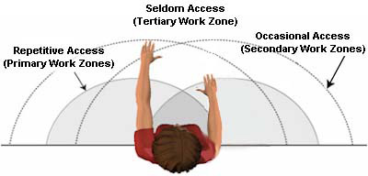Figure 3. Recommended zones for workplace components

**Potential Hazard**

Some desks and computer equipment have hard, angled leading edges that come in contact with a user's arm or wrist (Figure 4). This can create [contact stress](https://www.osha.gov/etools/computer-workstations/components/desks#stress), affecting nerves and blood vessels, possibly causing tingling and sore fingers.

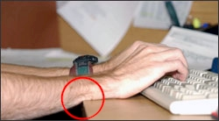Figure 4. Contact stress from the table edge

**Possible Solutions**

To minimize contact stress:

* Pad table edges with inexpensive materials such as pipe insulation.
* Use a [wrist rest](https://www.osha.gov/etools/computer-workstations/components/wrist-palm-support).
* Buy furniture with rounded desktop edges.

[**Areas under the desk or work surface**](https://www.osha.gov/etools/computer-workstations/components/desks#accordion-70047-collapse2)

1. Areas under the desk or work surface

**Potential Hazard**

Inadequate clearance or space under the work surface may result from poor design or excessive clutter. Regardless of the cause it can result in discomfort and performance inefficiencies, such as the following:

* Shoulder, back, and neck pain due to users sitting too far away from computer components, causing them to reach to perform computer tasks.
* Generalized fatigue, circulation restrictions, and [contact stress](https://www.osha.gov/etools/computer-workstations/components/desks#stress) due to constriction of movement and inability to frequently change postures.

**Possible Solutions**

* Provide, to the extent possible, adequate clearance space for users to frequently change working postures ([see recommended dimensions](https://www.osha.gov/etools/computer-workstations/components/work-space)). This space should remain free of items such as files, CPUs, books, and storage (Figure 6).
* Be sure clearance spaces under all working surfaces accommodates at least two of the three seated [reference working postures](https://www.osha.gov/etools/computer-workstations/positions#pictures), one of which must be the upright seated posture.
* Limit the number of items that are stored under the work surface. There should be no items stored that will limit the space needed for workers' legs and feet.

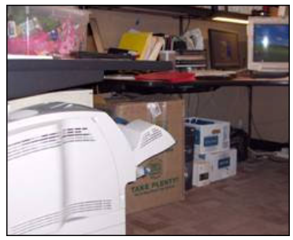

*Figure 5. Clutter under work top limits space for legs and chair positioning*

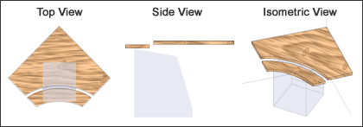Figure 6. Diagram of clearance area under a work surface

**Potential Hazard**

Desk surfaces that are too high or too low may lead to awkward postures, such as extended arms to reach the keyboard, and raised shoulders.

**Possible Solutions**

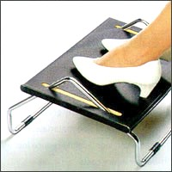

Figure 7. Footrest

* Raise work surfaces by inserting stable risers such as boards or concrete blocks under the desk legs if necessary.
* Remove center drawers of conventional desks to create additional thigh clearance if necessary.
* Lower work surfaces by cutting off desk legs if necessary. If the work surface cannot be lowered, raise the [chair](https://www.osha.gov/etools/computer-workstations/components/chairs) to accommodate the user. If needed, provide a footrest to support the user's feet (Figure 7).
* Provide height-adjustable desks. Clearance for the legs, under the desktop, should generally be between 20-28 inches (50-72 cm) high.

**3.**[**Workstation Components**](https://www.osha.gov/etools/computer-workstations/components)**» Document Holders**

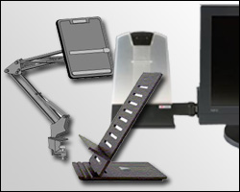

Document holders keep printed materials needed during computer tasks close to the user and the monitor. Proper positioning of document holders depends on the task performed and the type of document being used. Appropriate placement of the holder may reduce or eliminate risk factors such as awkward head and neck postures, fatigue, headaches, and eye strain.

* [Source document position](https://www.osha.gov/etools/computer-workstations/components/document-holders#accordion-70058-collapse1)

The position of the document holder is also related to the placement of the [monitor](https://www.osha.gov/etools/computer-workstations/components/monitors), [keyboard](https://www.osha.gov/etools/computer-workstations/components/keyboards), and a well-adjusted [chair](https://www.osha.gov/etools/computer-workstations/components/chairs).

**Document Holder Quick Tips**

* Documents should be at the same height and distance as the monitor.

1. Source document position

**Potential Hazard**

Documents positioned too far from the monitor may require [awkward](https://www.osha.gov/etools/computer-workstations/components/document-holders#posture) head postures or [frequent movements](https://www.osha.gov/etools/computer-workstations/components/document-holders#repetition) of the head and neck to look from the monitor to a document. Those awkward postures can lead to muscle fatigue and discomfort of the head, neck, and shoulders.

**Possible Solutions**

* Document holders should
  + Allow you to place documents at or about the same height and distance as the monitor screen (Figure 1), and
  + Be stable when loaded with heavier documents such as a textbook (Figure 2).
* A document holder can be positioned directly beneath the monitor (Figure 2). This provides a sturdy writing surface, if written entries are necessary, and reduces frequent movement of the head, neck, or back.
* Task lighting on the document should not cause [glare](https://www.osha.gov/etools/computer-workstations/workstation-environment#accordion-70143-collapse2) on the monitor.

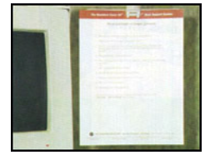

*Figure 1. Screen and document holder are close together and same distance from the eye*

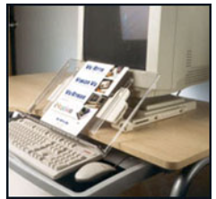

*Figure 2. Example of in-line document holder*

4.